**Manual**

**Of**

**AL NAHDI SAFARIS**

**Website**

#### 

#### 1. SIGNUP

**Step1.**Go to homepage, if you already registered then click on login

**Step2**. If you don’t have an account? Click on get started and fill all field.

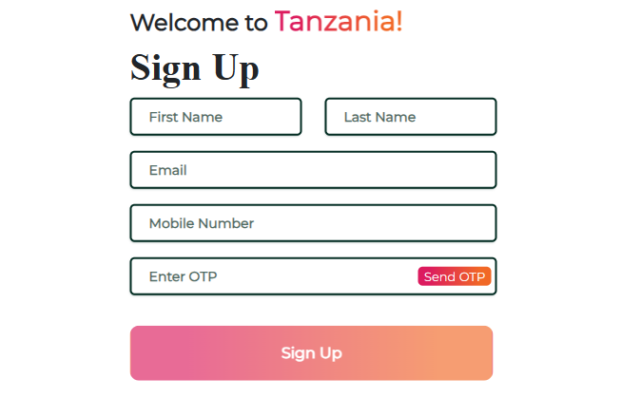

#### 1.1 logging in

**Step1** Enter your mobile number then click on send OTP and press enter

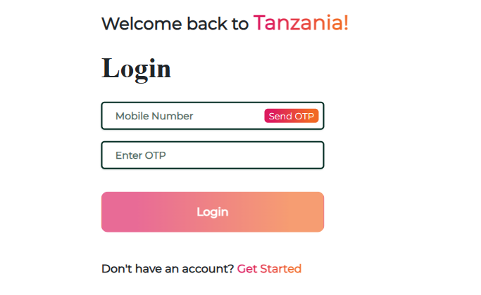

#### 2. Go to User Profile

From your account dashboard you can manage your billing address and edit your password and account details.

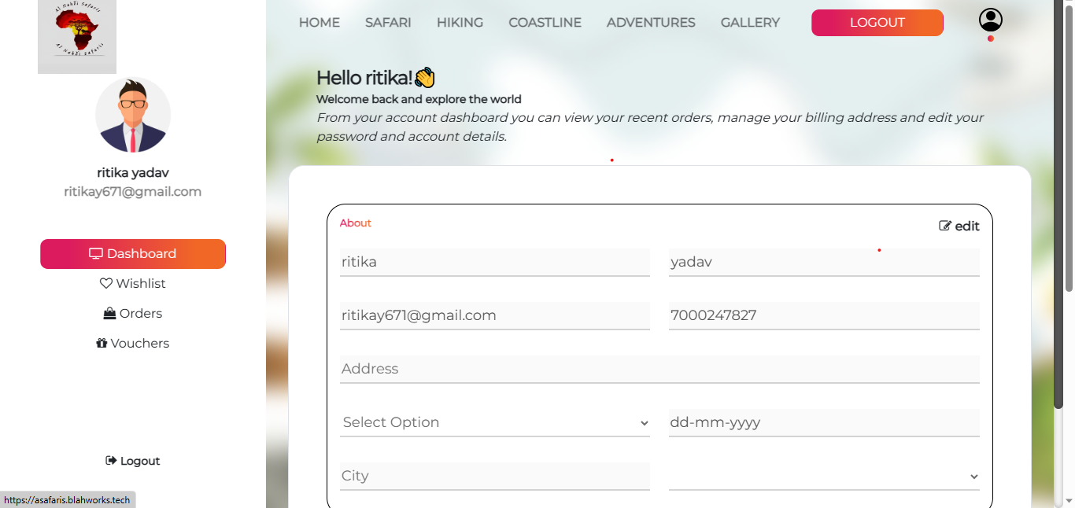

#### 2.1 WISHLIST :

Click on Wishlist icon , you can view your wishlist .

#### 

**3. How to find tours :**

Go to homepage , fill all field and you can find tour easily.



#### 3.1 SAFARI:

Here you can see all safari’s and you can also Explore particular tour.



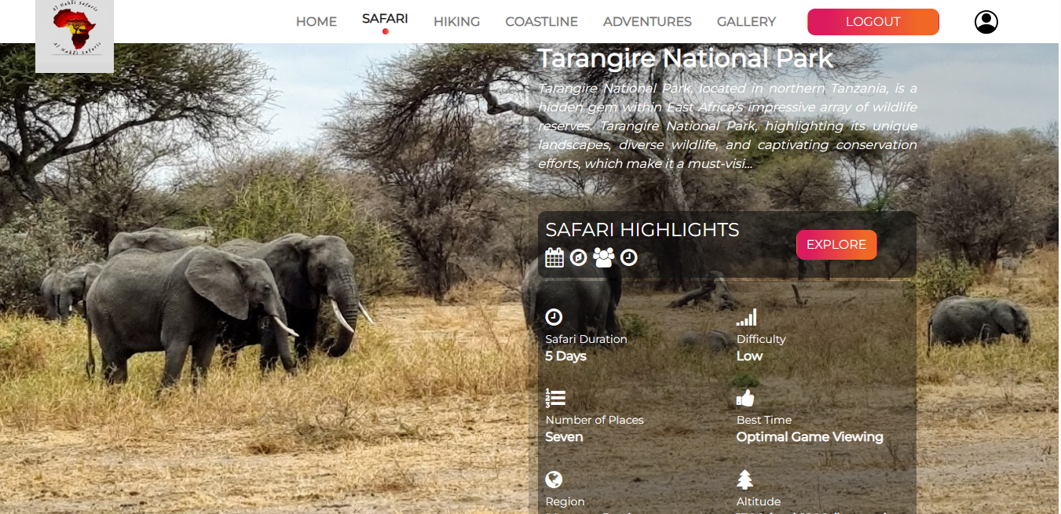

#### 3.2 HIKING :

Here you can see all HIKING and you can also Explore particular tour.

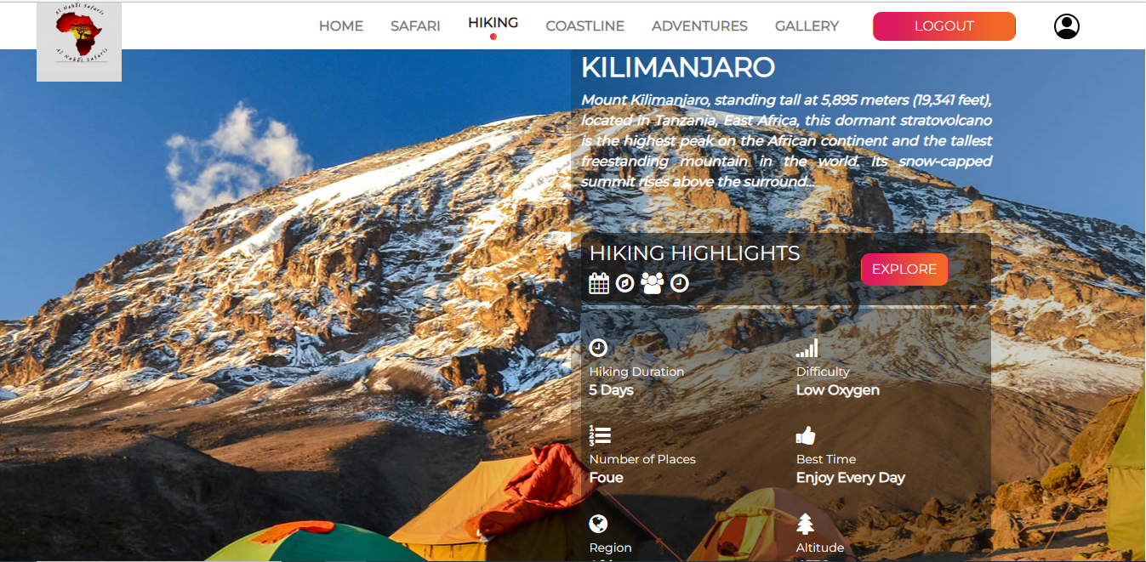

#### 3.3 COASTLINE :

Here you can see all COASTLINES and you can also Explore particular tour.



#### 3.4 ADVENTURES :

1. Here you can see all ADVENTURES and you can also Explore particular tour.

2. Click on GET ITINERARY and download PDF.

1. Click on PROCEED BOOKING and you can choose options like tour date,package type, boarding point etc.
2. Then,open cheakout page ,you can see information and also apply coupon.

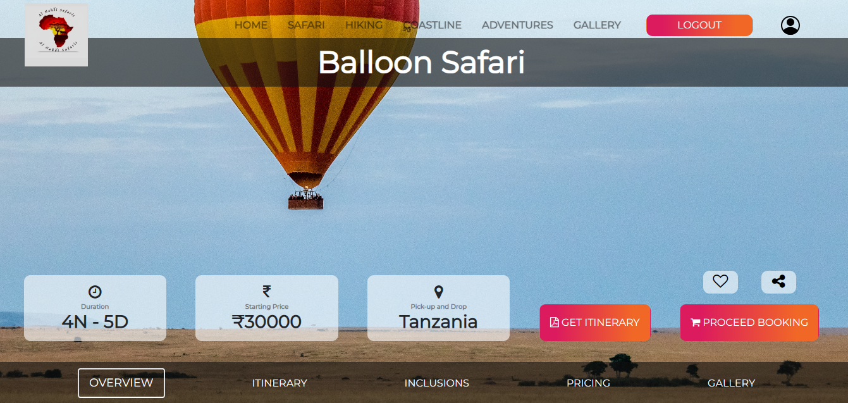

#### Now the next step:

#### 

#### 

#### 4. ORDERS:

Click on orders icon and you can view order history

#### 

#### 4.1 Click on view more icon ,you can view order history and with the help of cancel icon you can cancel tour or cancel members.

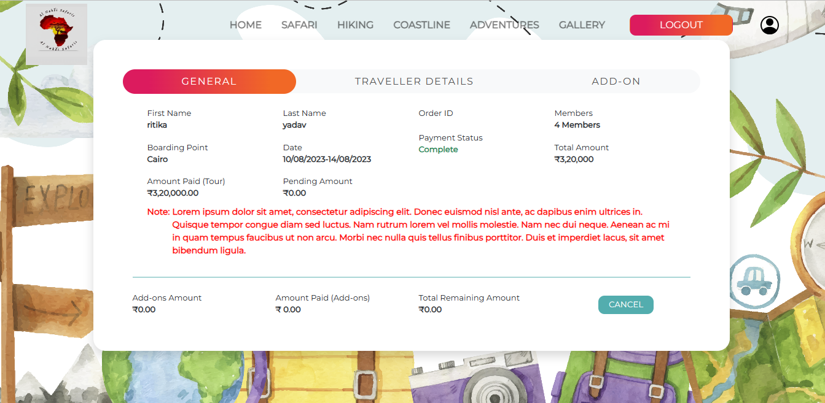

#### GALLERY :

Here you can see all uploaded photos.

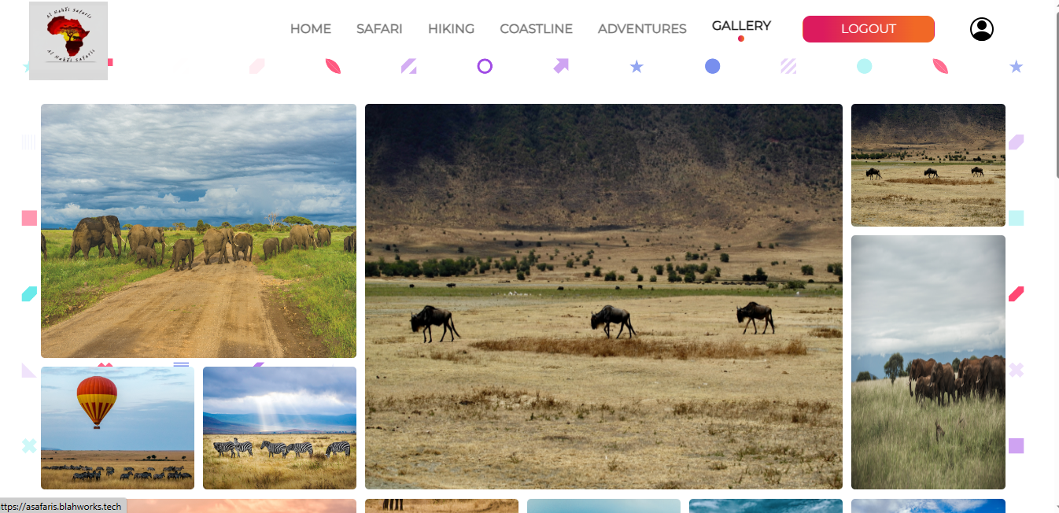

#### ENQUIRY:

